8.80: a) From the derivation in Sec. 8.4 of the text we have

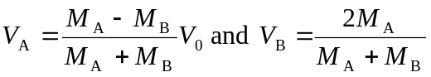

The ratio of the kinetic energies of the two particles after the collision is

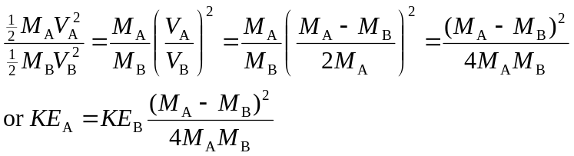

b) i) For 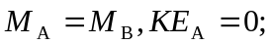 i.e., the two objects simply exchange kinetic energies.

ii) 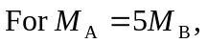
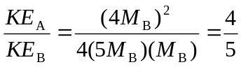
i.e., 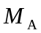gets 4/9 or 44% of the total.

c) We want

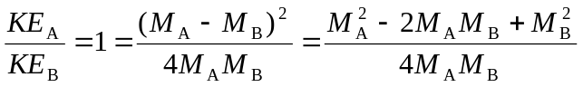

which reduces to

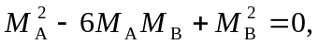

from which, using the quadratic formula, we get the two possibilities 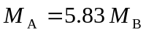and

